Senegal

## GNI per capita and development level

The data set shows the GNI per capita and development level of the country each year.

## # A tibble: 19 x 5  
## country iso3c date GNIperCapita devCategory   
## <chr> <chr> <dbl> <dbl> <chr>   
## 1 Senegal SEN 1996 1012. Low Income   
## 2 Senegal SEN 1998 1056. Lower Middle Income  
## 3 Senegal SEN 2000 1098. Lower Middle Income  
## 4 Senegal SEN 2002 1102. Lower Middle Income  
## 5 Senegal SEN 2003 1151. Lower Middle Income  
## 6 Senegal SEN 2004 1191. Lower Middle Income  
## 7 Senegal SEN 2005 1227. Lower Middle Income  
## 8 Senegal SEN 2006 1229. Lower Middle Income  
## 9 Senegal SEN 2007 1256. Lower Middle Income  
## 10 Senegal SEN 2008 1275. Lower Middle Income  
## 11 Senegal SEN 2009 1257. Lower Middle Income  
## 12 Senegal SEN 2010 1268. Lower Middle Income  
## 13 Senegal SEN 2011 1244. Lower Middle Income  
## 14 Senegal SEN 2012 1271. Lower Middle Income  
## 15 Senegal SEN 2013 1270. Lower Middle Income  
## 16 Senegal SEN 2014 1313. Lower Middle Income  
## 17 Senegal SEN 2015 1353. Lower Middle Income  
## 18 Senegal SEN 2016 1393. Lower Middle Income  
## 19 Senegal SEN 2017 1452. Lower Middle Income

## GDP growth and economic growth classification

The data set shows the GDP growth and the ecomic growth classification of the country each year.

## # A tibble: 19 x 5  
## country iso3c date GDPannualGrowthRate GDPgrowthCategory4  
## <chr> <chr> <dbl> <dbl> <fct>   
## 1 Senegal SEN 1996 2.01 slow growth   
## 2 Senegal SEN 1998 5.90 fast growth   
## 3 Senegal SEN 2000 3.20 moderate growth   
## 4 Senegal SEN 2002 0.655 slow growth   
## 5 Senegal SEN 2003 6.68 fast growth   
## 6 Senegal SEN 2004 5.87 fast growth   
## 7 Senegal SEN 2005 5.62 fast growth   
## 8 Senegal SEN 2006 2.46 slow growth   
## 9 Senegal SEN 2007 4.94 moderate growth   
## 10 Senegal SEN 2008 4.06 moderate growth   
## 11 Senegal SEN 2009 2.09 slow growth   
## 12 Senegal SEN 2010 3.56 moderate growth   
## 13 Senegal SEN 2011 1.46 slow growth   
## 14 Senegal SEN 2012 5.12 moderate growth   
## 15 Senegal SEN 2013 2.82 moderate growth   
## 16 Senegal SEN 2014 6.61 fast growth   
## 17 Senegal SEN 2015 6.37 fast growth   
## 18 Senegal SEN 2016 6.36 fast growth   
## 19 Senegal SEN 2017 7.41 fast growth

## Development trend

The plot shows the development trend of the country.

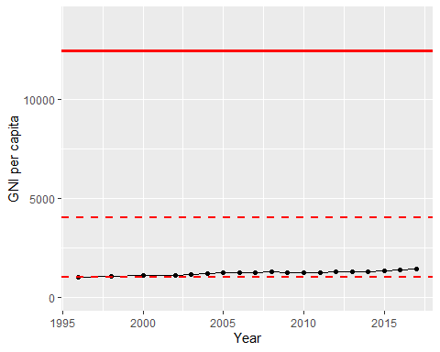

GNI Per Capita Trend